**Aim – Lab - Azure Release Pipelines - Azure Web Apps - Setup**

🡪 How to use Azure Release Pipelines.  
🡪 We will see how to use Azure Release Pipelines to deploy a web application onto an Azure Web App.

1. Create a Web app.

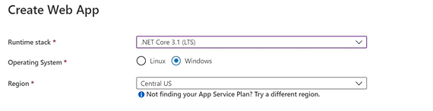

1. **Create a new build pipeline with your .Net core code**
2. **From pipeline yaml remove testing part as we don’t need that at this stage, then save and run the build.**

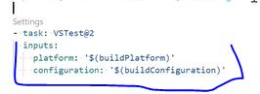

1. **Now go to Releases**

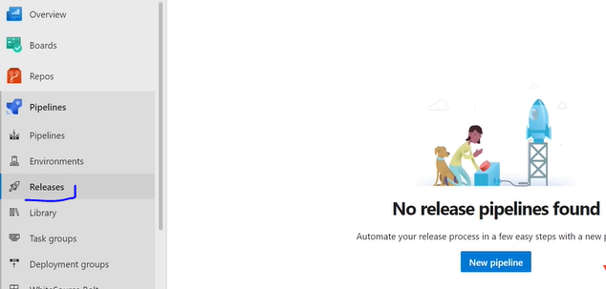

1. **Select appropriate template , like for our app we have to choose Azure app Service deployment.**

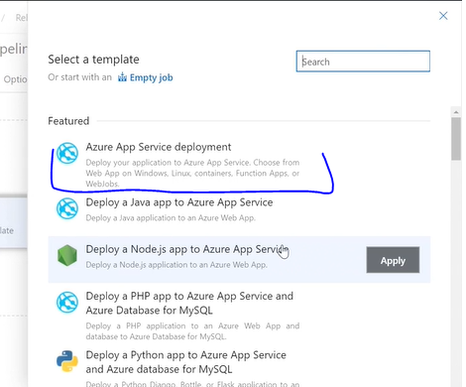

**6. Define stage name like QA, testing something like**

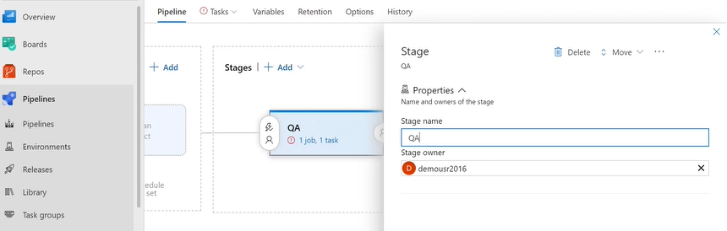

**7. It will look like this, having 1 job and 1 task.**

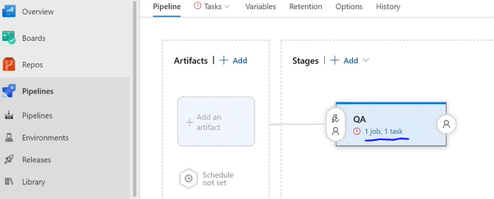

**8.** Next thing we have to do, add artifact , is to go ahead and add an advert. **So the artifacts are the build that is produced from our build pipeline, that will be transferred to a QA stage onto our destination as your web up.**

**9. Meanwhile , check if your web app deployment has been complete. Copy Web app URL.**

**10. Now go to build pipeline if it has been done, now edit the pipeline to publish artifacts.**

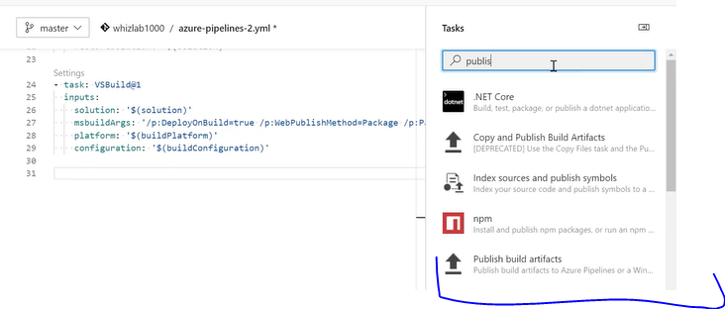

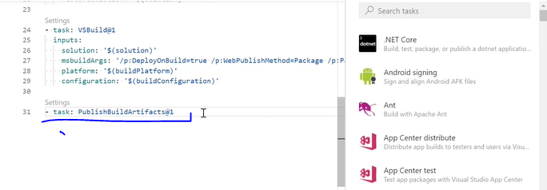

**Save and Run another build.**

**11) Go to release pipeline and checkput Artifacts section and click on Add**

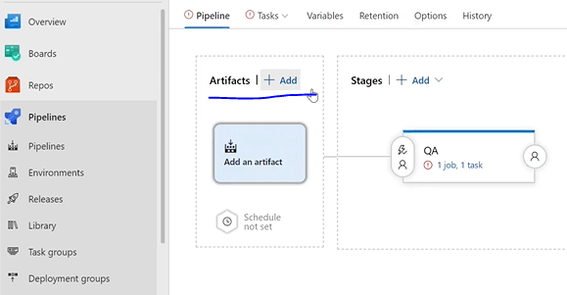

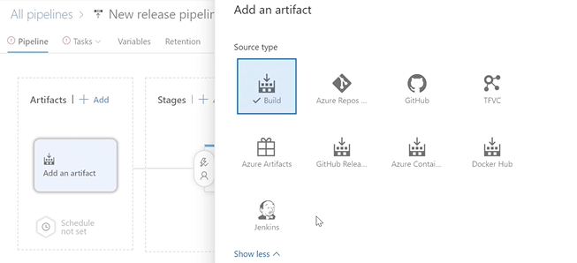

**12) Select your project and source build pipeline in above section.**

**If you want you can change release pipeline name also.**

**13) Now go to QA stage 🡪 go to tasks**

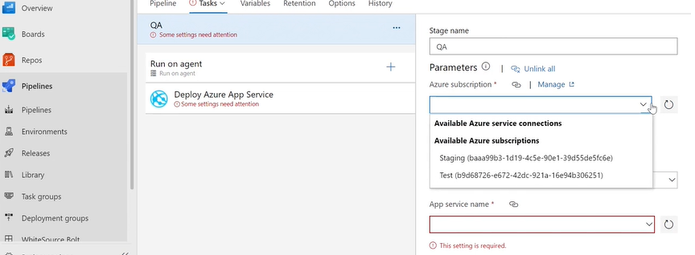

**14) in your build pipeline check if you have artifact which has been published recently and available under drop container.**

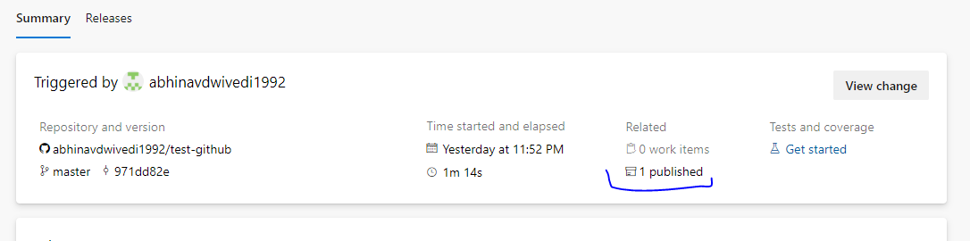

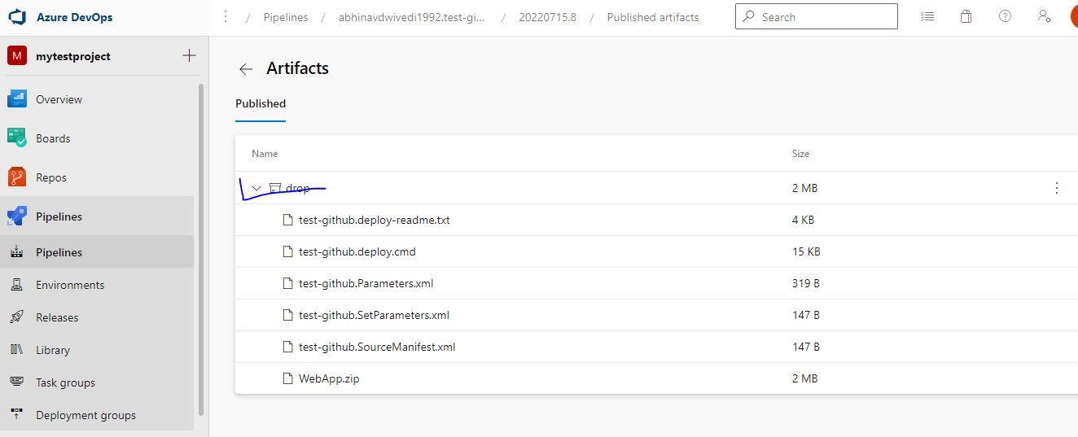

**15) Now we have to send this artifact over onto the release pipeline. [Till here we are ready with our setup]**

Now we will see if any changes in build and trigger release pipeline.

**Azure Release Pipelines - Azure Web Apps - Continuous Delivery**

We are ready with our setup, it’s time to create a release so first we will do it manually.

Click on create release to create manually.

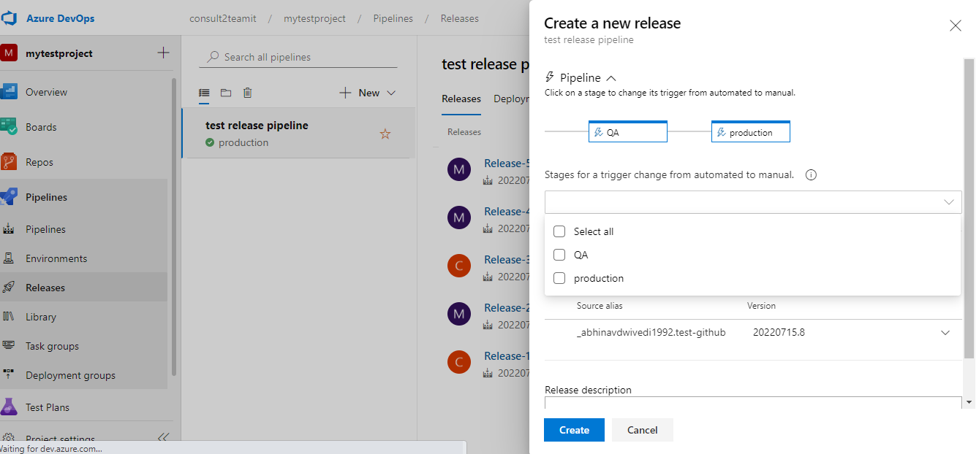

Create release and save. And click on Deploy , if everything goes well, you will get window like this.

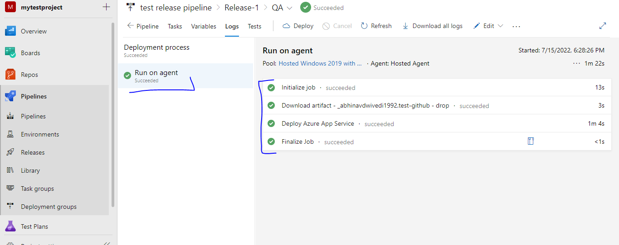

Once your deployment get completed go to your web app url and check it if any changes has been done in that or not.

**Now we will try to automate this entire process.**

Go to release pipeline 🡪 Edit release pipeline 🡪 click on this continue deployment trigger.

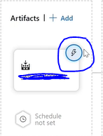

Once click you will get window like given below. Made changes and save this.

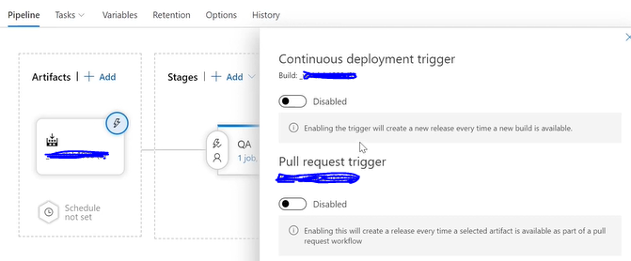

**Now we have to enable 🡪 Continuous deployment trigger option.**

It ensures whenever the changes will happen at master branch it will enable and or trigger this particular release pipeline.

**You will there is a tick symbol next to the lightning bolt for the trigger for the artifacts for this particular pipeline.**

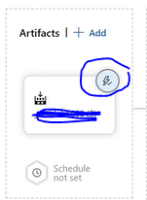

**Now we have to go to build pipeline and need to make changes in git repo to verify if our release if working fine or not.**

**For that go to your code base and make some changes into that.**

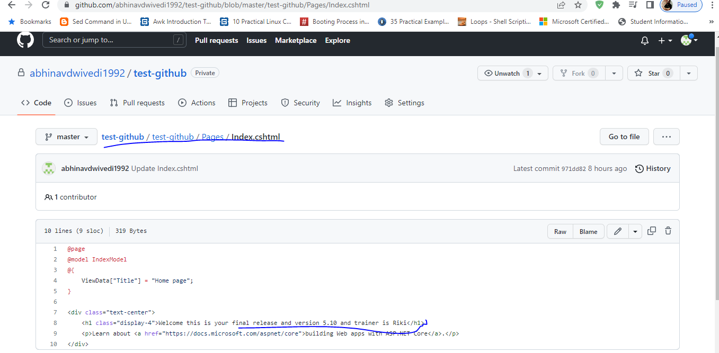

**Once you will make any changes in repo, first build pipeline will execute then release pipeline.**

**Build pipeline (If completed) 🡪 Check in release pipeline you will get new release pipeline like ‘Release-2 , Release-3’ something.**

QA stage will look like this.

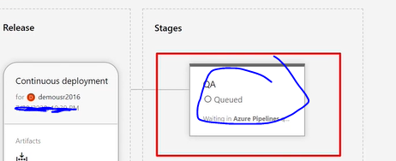

Wait for deployment get completed, now go to web app url, you will see the changes which you have done.

**How we will set up multiple stages in pipelines**

You can create another web app (you can choose your existing one also). We will go with existing one.

Go to releases and click on edit.

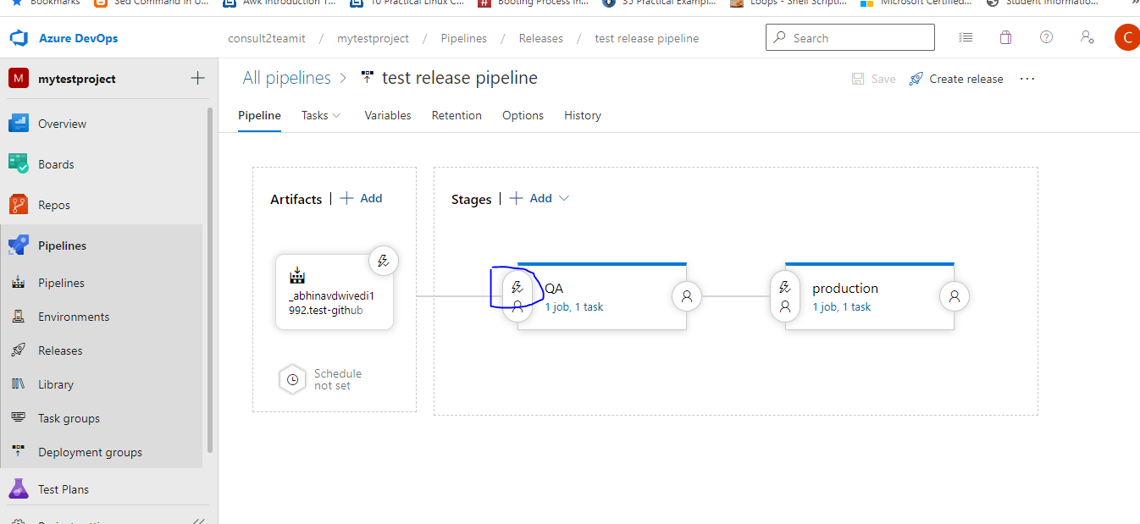

Click on predeployment conditions and make sure we don’t have any conditions in that.

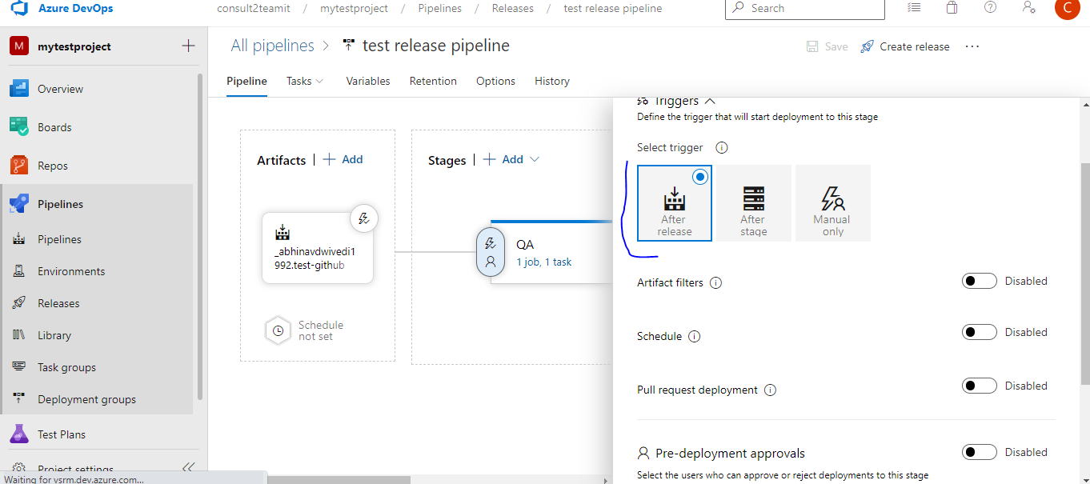

Now we have to add another stage and select same template , for example we have taken production.

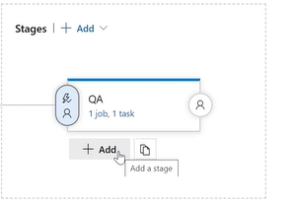

Click on task.

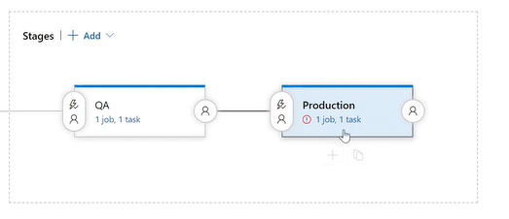

Go to the task and complete this section again.

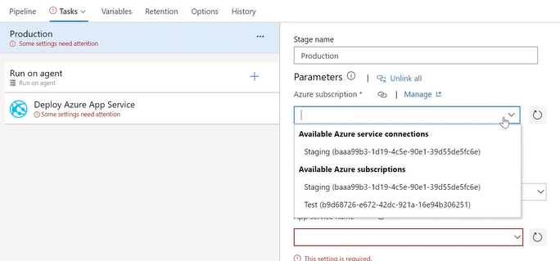

**Now need to make changes in git repo For that go to your code base and make some changes into that.**



**Go to your web app url and check what we are getting . Wait for release get completed both [build and release], once done check web url again.**